URL; <http://www.obstetrics.co.nz/delivery-postnatal-care.html>

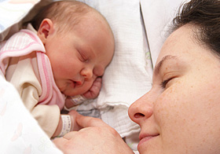 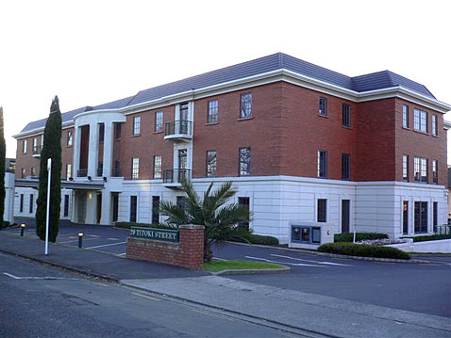

AOC is a unique practice made up of six specialist obstetricians and support staff. We work as a team sharing patient care and expertise to provide the highest standard of pregnancy and birth care.

Together we have many years of experience. All of us feel privileged to be able to share in the care of women during their pregnancy.

AOC provides a full range of care including pre-pregnancy advice, antenatal, labour, birth and postnatal care.

We also have an obstetric physician and paediatrician based at our centre and close links with physiotherapists, lactation consultants, psychologists and midwives to provide complete pregnancy care.

We hope you find the information contained on our website helpful in making your choice for a lead maternity carer.

**Doctor’s credentials**

Obstetricians

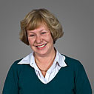

Lynda Batcheler

MB ChB MRCOG FRANZCOG

Lynda has been in private practice since 1990 and looking after pregnant woman for nearly 25 years. She has expertise in high risk pregnancies and has an interest in recurrent miscarriage as well as general gynaecology. She also runs a weekly antenatal clinic at Auckland City hospital. Lynda has three teenage children.

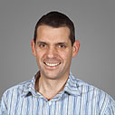

Tim Dawson

MBChB FRANZCOG

Tim graduated from the University of Auckland in 1994. He trained in obstetrics and gynaecology in New Zealand and the United Kingdom. As well as his work with AOC, Tim is a specialist Obstetrician and Gynaecologist at Auckland City Hospital, running weekly hospital antenatal clinics and sub-specialising in urogynaecology. He is married with three young children.

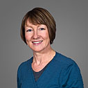

Gillian Gibson

MB ChB MRCOG FRANZCOG

Gillian has been in private practice since 1996. As well as specialising in general and high-risk obstetrics she has a sub-specialty interest in colposcopy. She is a part-time consultant at Auckland City Hospital. She is chairperson of the New Zealand branch of the Royal Australian and New Zealand College of Obstetricians and Gynaecologists. Gillian also sits on the Ministry of Health's maternity planning strategic advisory committee. Gillian is married with one young daughter.

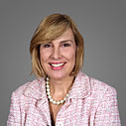

Eva Hochstein

MB ChB FRANZCOG

Eva graduated from University of Auckland, training in obstetrics and gynaecology in Sydney. She joined AOC in 1998 after working in private practice in Sydney. She also has an interest in general gynaecology and colposcopy. Eva has twin boys.



Paul Macpherson

MB ChB MRCOG FRANZCOG

Paul has been in private practice since 1994 specialising in high risk pregnancy and general gynaecology with a sub-speciality interest in urogynaecology. He also works part-time at Auckland City Hospital as the lead consultant in the hospital's urogynaecology service. Paul is a senior specialist in the hospital's gestational diabetes clinics. Paul is married with four teenage children.

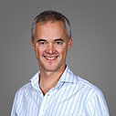

Martin Sowter

BSc MB ChB MD FRCOG FRANZCOG

Martin graduated from the University of Birmingham in 1988 and then trained in Bristol before coming to New Zealand in 1995 to spend three years doing research for an MD thesis at National Women's Hospital. He returned permanently to Auckland as a specialist in 2001. He is a part-time specialist at Auckland City Hospital in the fertility and menstrual disorders clinics. Martin is also one of the coordinators of the hospital's obstetric emergencies training programme for midwives and medical staff. He is a part-time specialist at Repromed Auckland. Martin is married with two daughters, the youngest delivered under the care of AOC.

**Doctor in pediatric**

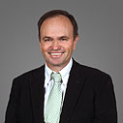

Peter Nobbs

MB ChB FRCPC

Peter graduated from the University of Auckland in 1977. He trained in paediatrics in Auckland and then at McMaster University, Ontario, before returning to National Women's as a specialist in paediatrics and neonatology in 1988. He worked as a paediatrician and neonatologist at National Women's until entering full time private practice in 2004. Peter's particular interest is in newborns and children up to 24 months of age. As well as clinics every week at AOC he is also able to attend deliveries and see newborn babies post-natally at National Women's and Birthcare. Peter has two children at university.

**Contact us**

**Physical:** Ground Floor, Birthcare Building, 20 Titoki Street, Parnell

**Postal:** PO Box 109 276, Newmarket, Auckland

**Phone:** + 64 9 367 1200

**Email:** [aoc@obstetrics.co.nz](mailto:aoc@obstetrics.co.nz)